Dis-Eur-Bulgaria-Venus Figurine, 6th millennium BCE- silicified sandstone

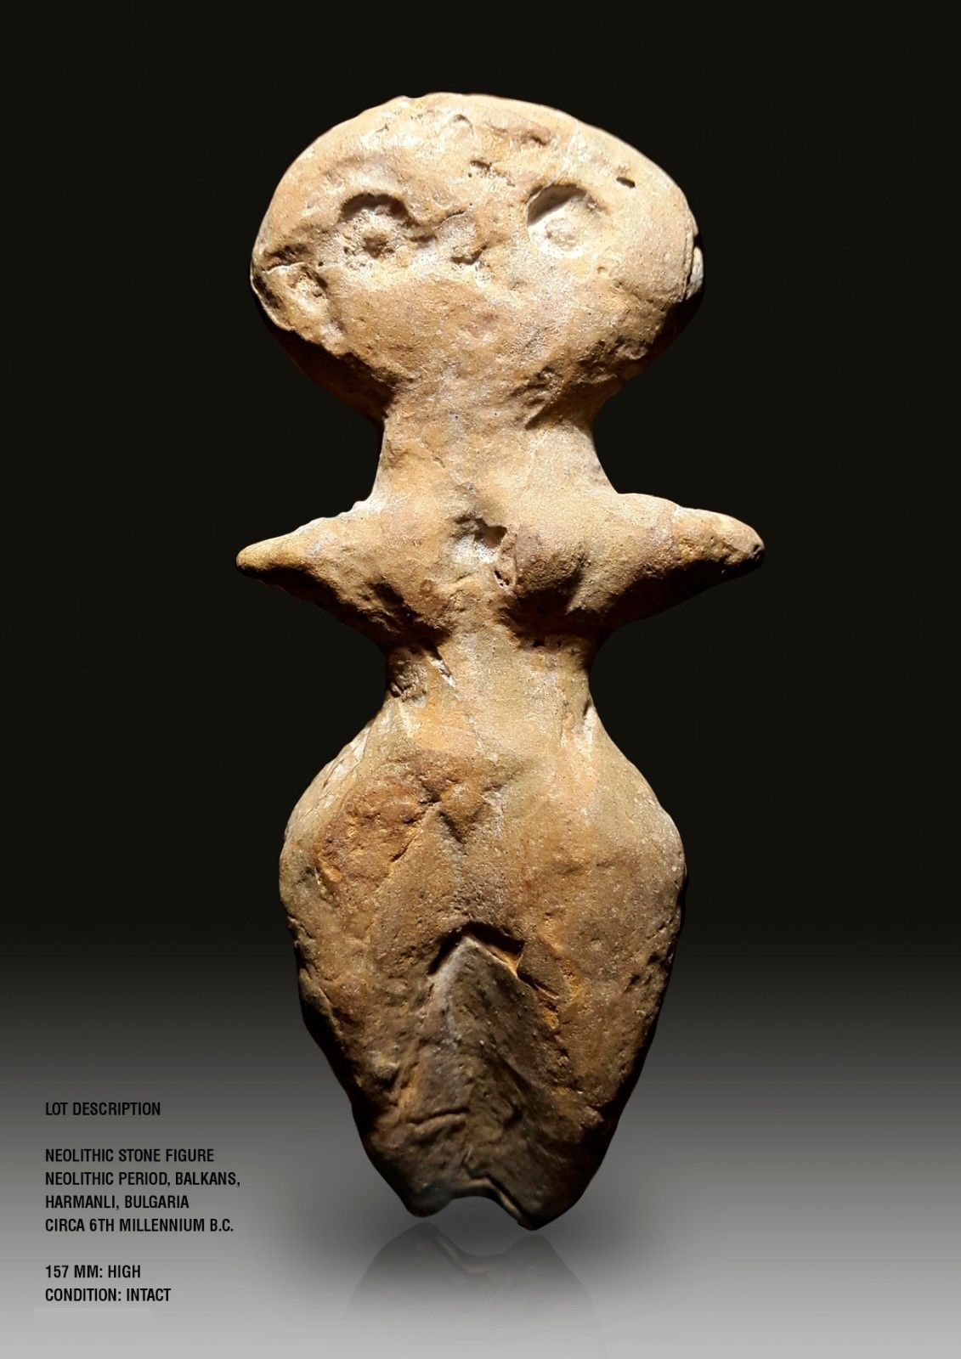 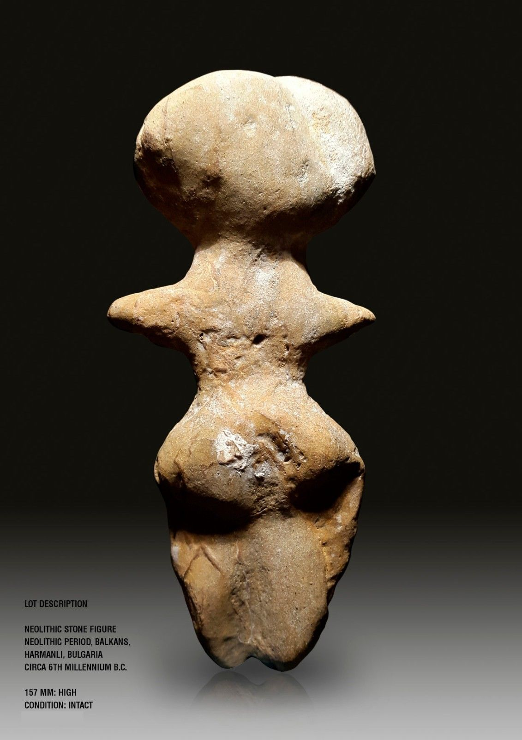

Formal Label: Venus Figurine, Bulgaria, 6th millennium BCE, silicified sandstone

Accession Number:

Date or Time Horizon: 6th millennium BCE

Geographical Area: Bulgaria

Cultural Affiliation: Neolithic

Medium: silicified sandstone

Dimensions: H 157 mm

Weight:

Provenance: Italian Private Collection; then Martin Dimov, Mladost 2, 239/3/3/88 1799 Sofia, Sofia Bulgaria

: